What I don’t like

I don’t like:

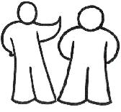

People getting too close

When you don’t tell me what you are going to do

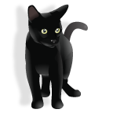

Cats and going on boats

